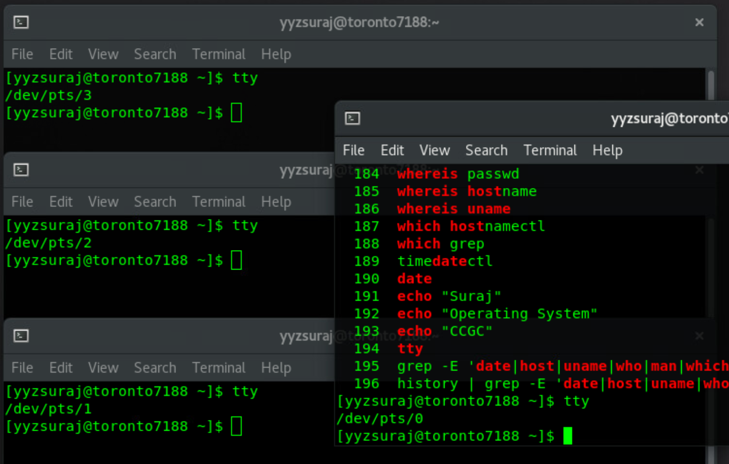

MONTREAL

